Module Generator User Manual

Prepared for

|  |  |
| --- | --- |
|  | County of Los Angeles,  Department of Beaches and Harbors |

**APPROVED:**

|  |
| --- |
| Los Angeles County – Functional Lead |
|  |
| Los Angeles County – Functional Lead |
|  |
| Los Angeles County – Technical Lead |

January 17, 2018

Table of Contents

1 Introduction 1

1.1 Overview 1

1.2 Business Need 1

2 User Interface 3

2.1 Home User Interface 3

2.2 Edit Department 4

# Introduction

* 1. Overview

(This overview is copied from DotNetNuke Module Creator document) DotNetNuke is a web application framework with a mission to make web software development simpler and more productive for the average developer. DotNetNuke provides a variety of specialized services that add value over what is available in the standard ASP.NET framework. These include, but are not limited to, a full framework for developing modular web applications, an extensibility model to add extensions to customize the platform to meet your needs, a robust security model which allows granular control over the activities a user can perform in the application, user interface patterns and controls to create a consistent modern user experience, and a skinning engine that allows you to transform the appearance of the application to match your branding.

Every software development platform has its own unique characteristics and conventions which new developers need to understand in order to be effective. The majority of developers are familiar with developing web applications by creating new code assets on the file system, editing the source code in an IDE, and accessing these code assets by direct URL paths in a web browser.

However, because DotNetNuke is a modular CMS application, there is both a file system and database configuration required in order to develop and expose extensions. The file system and the database are wired up based on some unique conventions which are specific to DotNetNuke, which imposes an initial barrier to entry for new developers.

The DotNetNuke Portal application was highly successful at providing a simple “getting started” experience for developers who wanted to get up to speed on ASP.NET. The application was simple and “hackable” by developers with limited experience, yet it was still capable of being utilized in enterprise scenarios as well. This encouraged rapid adoption of ASP.NET and in fact, provided the initial momentum for the DotNetNuke ecosystem growth.

For developers on the Microsoft platform who are familiar with ASP.NET we usually tell them that the DotNetNuke development model is consistent with what they are used to – that they just need to create User Controls ( *.ascx ) instead of Pages ( *.aspx ). The reality is that it is significantly more involved than that, with the initial challenge being where to start in terms of coming up to speed on the specifics of the DotNetNuke architecture, environment, and conventions. It is only after a developer navigates past this first step, that they can then utilize their ASP.NET skills productively and understand the value of the platform.

* 1. Business Need

Traditionally, developers have had to rely on documentation and sample modules in order to obtain the knowledge required to become productive on the platform. Unfortunately, the documentation and sample modules are not well organized, nor are they focused on specific developer personas or why one approach is better than another depending on the business scenario. This is not an optimal model. Over the years, there have been a number of different approaches to attempt to deal with this problem.

In this module, we overhauled the “Create New Module” user interface to reduce the number of steps required to create some basic module assets on the file system. This was done in the application itself which made it slightly more discoverable and it did deal with both the file system and database configuration, in order to get up and running.

We have the opportunity to improve the developer experience and solve the problems outlined above.

# User Interface

This module can be used by users with host role only.

There are 3 main interfaces:

* Home: Home page for Module Generator to generate the new module based on specific department.
* Edit Department: a web page for insert/update/delete departments.
* Manual: a web page to display this document.
  1. Home User Interface

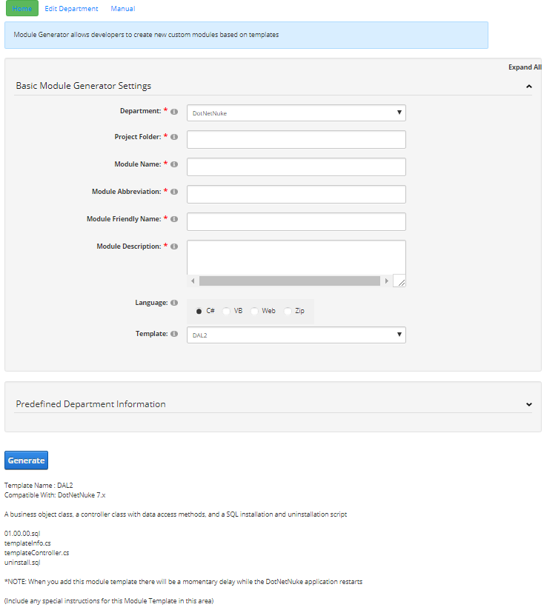

* 1. Edit Department

